VISUAL JOURNAL

ADVANCED STUDIO PAINTING CLASS

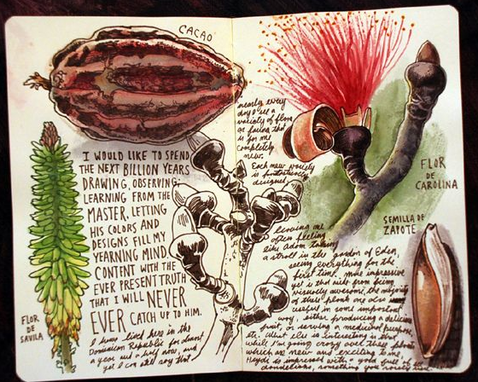
OBJECTIVE: The “Visual Journal” (sketchbook) is an important resource for information of: ideas (visual & written), technique samples, all things related to your painting projects.

SKETCHES*: Workout construction issues, abstract ideas, proportions, surface textures, color schemes, etc. Label sketches, and be specific when you make notes; with complete sentences! Your notes should include techniques, types of media, tools used, etc.
*Drawings/sketches should be made to the best of your abilities.

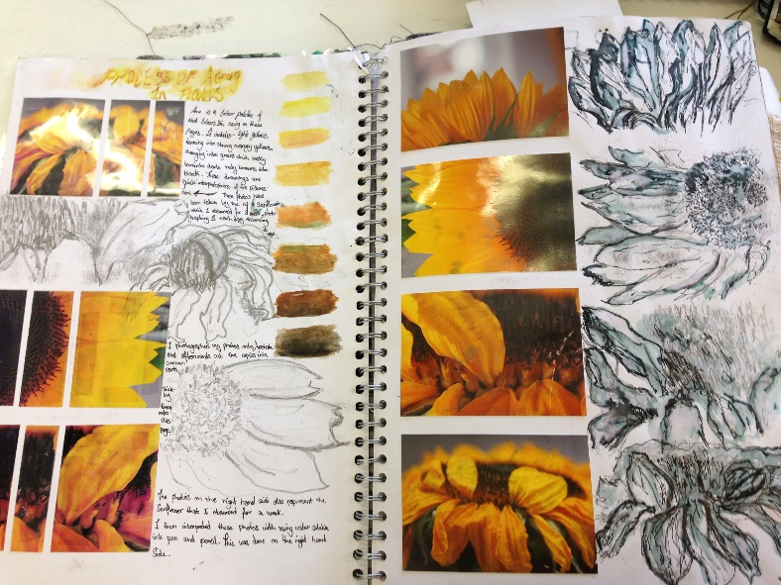

Photos you have taken, or have permission to use may be inserted into your journal. You should, also, include: Inspirational magazine pictures & text, surface decoration, etc.

CLASS: All handouts, notes from demos & presentations, and any other important information should be attached in your journal.

MAJOR PROJECTS: a self - evaluation/critique, or Artist Statement will be written on the completion of each major project in your journal, be sure to include photos of each of your projects.
PLAY PROCCESS PRACTICE PRODUCT

